**SVKM’s NMIMS**

**Mukesh Patel School of Technology Management & Engineering**

**Computer Engineering Department**

Program: MBA.Tech.Sem V

**Course: Image Processing**

**List of Experiments**

w.e.f. 1stJuly 2020

**Faculty:** Dr. PrachiNatu

|  |  |  |  |
| --- | --- | --- | --- |
| **Exp No.** | **Title** | **Prerequisite\*** | **CO#** |
| 1 | **Introduction to Image Processing using Matlab.** (Imread, Imwrite, Imshow, size, resize, Addition, Subtraction, Multiplication and division of Images) | Refer the Matlab manual, Soft copy of your Photograph | CO1 |
| 2. | **To study the pixel relationship in the Image** (4,8,m connectivity and Use distance measures like Minkowaski Distance, Eucledian Distance, City Block, Chess board, Sum of absolute difference. ) | Knowledge of 4,8,M connectivity and Distance measure formulae, Soft copy of your Photograph | CO1 |
| 3. | **Implementation of Point Processing Operations in Spatial Domain.**  a. Negation of an image  b. Thresholding of an image  c. Contrast Stretching of an image  d. Gray level Thresholding  e. Bit Plane slicing. | Matlab programming syntax,  Knowledge of point processing operation, Soft copy of your Photograph | CO1 |
| 4 | Write a program to enhance the quality of image (on your own photograph) by noise removal (Histogram Equalization, HPF, LPF and Median filtering). | Matlab programming syntax,  Knowledge of filtering techniques, Soft copy of your Photograph | CO1 |
| ­5 | Apply various transforms (Hadamard, Walsh and DFT) on the image and compare its results. | Matlab programming syntax and knowledge of transforms, Soft copy of your Photograph | CO2 |
| 6 | Apply various transforms ( DCT, DST, Hartley, Slant) on the image and compare its results. | Matlab programming syntax and knowledge of transforms, Soft copy of your Photograph | CO2 |
| 7 | Perform second level decomposition of your photograph using Haar Wavelet | Matlab programming syntax and knowledge of Haar Wavelet, Soft copy of your Photograph | CO3 |
| 8 | Write a program to segment the given medical image using edge detection techniques: Robert, Prewitt and Sobel operators. | Matlab programming syntax, understaning of medical image, soft copy of brain tumour CT Scan image and knowledge of edge detection operators | CO4 |
| 9 | Write and execute program for given noisy finger print image and apply following image morphological operations in given order.   1. Opening of image 2. Opening followed by closing | Matlab programming syntax, understanding of medical image and knowledge of morphological operations, Soft copy of finger print image | CO4 |
| 10 | Write a program to compress the image (your own photograph) using energy conservation concept of Discrete cosine transform and calculate RMSE, PSNR and compression ratio. | Soft copy of your Photograph and knowledge of Image compression concepts | CO5 |
| 11 | Case study: Presentation on selected IEEE /ACM paper based on chosen image processing application. | Selected IEEE/ACM paper, Summary of the paper and PPT presentation |  |

* Students are expected to be ready with the prerequisite before attending the lab

LAB Manual

PART A

(PART A : TO BE REFFERED BY STUDENTS)

**Experiment No.01**

**A.1 Aim:**

To explore the fundamentals of Image Processing using basic Matlab functions and basic

mathematical image operations.

**A.2 Prerequisite:**

1. Understanding of fundamental programming functions/commands and environment of Matlab (Refer the Matlab manual),

2. Availability of Soft copy of your Photograph for experiment.

**A.3 Outcome:**

**After successful completion of this experiment students will be able to**

1. Use following Matlab functions/structures for programming.

clc, clear all, ‘; ’ operator, Imread( ), Imwrite( ), Imshow( ), size( ), resize( ), If statement, While, for loop.

1. Explore the Matlab workspace and understand the matrix representation of an Image
2. Write program segment to Perform following mathematical operations on one’s Photograph.
3. Addition of two images
4. Subtraction of one image with other
5. Multiplication of a value with an Image
6. Division of an Image

**A.4 Theory:**

**Introduction of MATLAB:**

MatLab is a programming language for mathematical operations It provides development environment for mathematical programming. It is very much useful for matrix manipulation hence it is good choice for signal processing and image processing applications.

Some commands and programs in MATLAB:

**[1] Declaring matrices:** In Matlab, there is no need to declare variables; new variables are simply introduced as they are required.

>>A = [1 2 3; 4 5 6; 7 8 9]

The above MATLAB command declares following matrix:



Keep following things in mind while declaring variables/matrices:

* No spaces
* Don’t start with a number
* Variable names are case sensitive

**[2] Populating matrix elements with zeros:**

Matlab also provides a number of functions which can be used to populate a new matrix with particular values. For example to make a matrix full of zeroes we can use the function **zeros(m, n)** which creates an m*n matrix of zeros as follows:

>>B = zeros(3,3)



**[2] Knowing size of matrix:**

Syntax:

**[rows, cols] = size(A);**

This function gives size of matrix Above command gives result: rows=3, cols=3

**[3] Reading Image file :**We can use following command to read image file:

**myImage=imread(‘File name with path’)**

If name of the image file is test.bmp and if it is in /home/chv folder above commands can be written as:

**myImage=imread(‘/home/chv/test.bmp’)**

The image filename can be given as a full file path or as a file path relative to the Matlab current directory. The current directory can be changed from the main Matlab interface window or by cd (change directory command). The supported file formats include ‘bmp’, ‘gif’, ‘jpg’ and ‘png’.

After giving above command image data is available in **myImage**variable. You can use any variable name.

**[4] Displaying image :**After reading image data using above function, we can display images in Matlab using **imshow**function. This function simply takes the array storing the image values as its only parameter.

Syntax:

**imshow(<variable name>)**

Example:

**imshow(myImage);**

**[5] Knowing size of image in pixels:**

Size of the image in pixels can be found out by following command:

**[Rows, Cols] = size(myImage)**

**[6] Image resizing :**Image resizing can be done by following command:

**imresize(Image,{Parameters});**

For example:

Consider that we read the image in variable myImage using imread function than we can resize the image stored in this variable by following command imresize(myImage,[256,256],’nearest’);

This command will convert image of any size into image of 256x256 using nearest neighbor technique.

[**7]Converting Color image into Grayscale image:** Color image can be converted into Grayscale image by Matlab command rgb2gray.

Example:

myGrayImage=rgb2gray(myImage)

**[8] Flow control in MATLAB:** If statements are simply used to make decisions in Matlab

Syntax:

*if<condition> then*

*<do some work>*

*else*

*<do some other work>*

*end*

**[9] Loops in MATLAB:** There is for loop and while loop in MATLAB.

**While loop**

While loop repeat a piece of work as long as a condition holds true. The while loop in Matlab uses the following syntax:

*while<condition>*

*<perform some work repeatedly…>*

*end*

For loop in MATLAB is very popular for image processing because it is particularly useful for iterating through the members of a matrix.

The MATLAB for loop uses the following syntax:

*for index = <start>:<finish>*

*<Perform some work…>*

*end*

**B. Mathematical operation on Images**

Digital images can be represented in matrix format. All Mathematical operations performed on matrix is possible on digital images. For example**Addition of two images** can be given by:

Eqn:eqnadd1

Or if it is simply desired to add a constant value *C* to a single image then:

Eqn:eqnadd2

**The subtraction of two images** is performed straightforwardly in a single pass. The output pixel values are given by:

Eqn:eqnsub1

Or if the operator computes absolute differences between the two input images then:

Eqn:eqnsub2

Or if it is simply desired to subtract a constant value *C* from a single image then:

Eqn:eqnsub3

**The multiplication of two images** is performed in the obvious way in a single pass using the formula:

Eqn:eqnmul1

Scaling by a constant is performed using:

Eqn:eqnmul2

**The division of two images** is performed in the obvious way in a single pass using the formula:

Eqn:eqndiv1

Division by a constant is performed using:

Eqn:eqndiv2

**A.5 Procedure/Algorithm:**

**A.5.1 TASK 1:**

1. Create new file in matlab

2. Write a program to Read Image file and display the read image file.

3. Execute the program

4. Check the Workspace and get familiarized with newly Image variable created with

Imread () function, Image matrix its content, size, availability of 3 colour planes.

1. Modify the above written program and use following functions on the same image and

observe the changes in workspace.

a. Imwriteb. size c. resize

d. ending each matlab statement with/without ‘;’ semicolon sign.

e. clc, clearall.

5. Modify the above program to experiment the use of following in matlab

a. if statement b. For loop c. While loop

6. Observe the output and complete PART B of lab manual.

7. Save and close the file and name it as **EXP1_Task1_your Roll no.m**

**TASK 2:**

1. Create a new matlab file.
2. Read your input images.
3. Add two images and observe the output (both workspace and displayed output) and write your comments.
4. Subtract one image from another image and observe output (both workspace and displayed output) write your comments.
5. Divide one image by 10, 50, 255 and observe output(both workspace and displayed output).
6. Multiply one image by 10, 20, 255 and observe the output(both workspace and displayed output).
7. Modify the above programs to show all input and output images on single output window.
8. Complete PART B of lab manual.
9. Save and close the file and name it as **EXP1_Task2_your Roll no.m**

**********************

PART B

(PART B : TO BE COMPLETED BY STUDENTS)

***(Students must submit the soft copy as per following segments within two hours of the practical. The soft copy must be uploaded on the Blackboard or emailed to the concerned lab in charge faculties at the end of the practical in case there is no Black board access available)***

|  |  |
| --- | --- |
| Roll No. N049 | Name: Tarun Tanmay |
| Class : MBA Tech CE | Batch : B3 |
| Date of Experiment: | Date of Submission |
| Grade : |  |

**B.1 Software Code written by student:**

***(Paste your Matlab code completed during the 2 hours of practical in the lab here)***

***Task1 and 2:***

clear all;

clc;

%IMAGE READ

img=imread('/Users/tjrox0825/Desktop/Tarun.png');

%IMAGE DISPLAY

subplot(1,4,1);

imshow(img);

[row,col]=size(img);

img_grey= rgb2gray(img);

subplot(1,4,2);

imshow(img_grey);

imwrite(img_grey,'grayimg.jpg')

%IMAGE RESIZE

re_size=imresize(img,[100,100]);

subplot(1,4,3);

imshow(re_size);

%IMAGE ADDITION

addimg= img + img;

subplot(1,4,4);

imshow(addimg);

%IMAGE SUB

subimg= img - img;

figure();

imshow(subimg);

%IMAGE DIV

img10=img/10;

figure();

imshow(img10);

img50=img/50;

figure();

imshow(img50);

img255=img/255;

figure();

imshow(img255);

%IMAGE MULTI

img10m=img*10;

figure();

imshow(img10m);

img20m=img*20;

figure();

imshow(img20m);

img255m=img*255;

figure();

imshow(img255m);

**B.2 Input and Output:**

***(Paste your program input and output in following format, If there is error then paste the specific error in the output part. In case of error with due permission of the faculty extension can be given to submit the error free code with output in due course of time. Students will be graded accordingly.)***

**Input Images:**

**images:**

1. **For each function used to read, write, show, size, resize the image.**

**Original image**

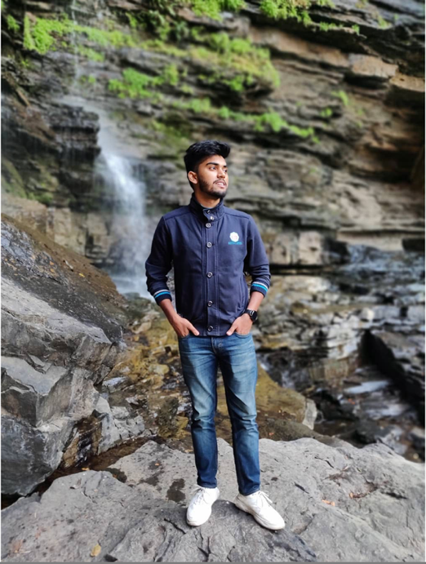

**grey Image(jpg)**

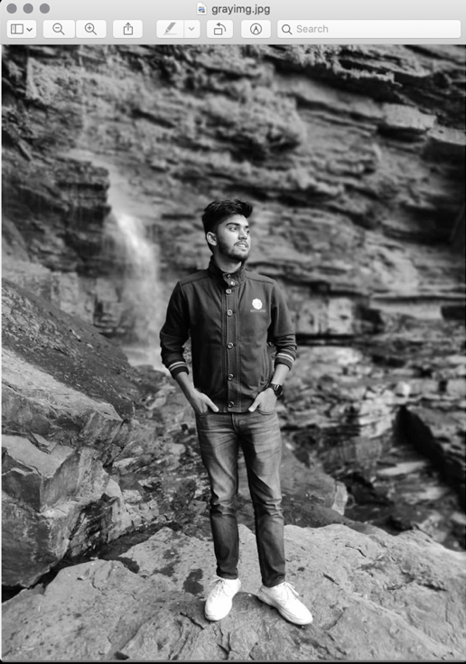

**Resized image**

**2. For each mathematical operations performed**

**Addition**

**Subtraction**



**Division**

**a)By 10**

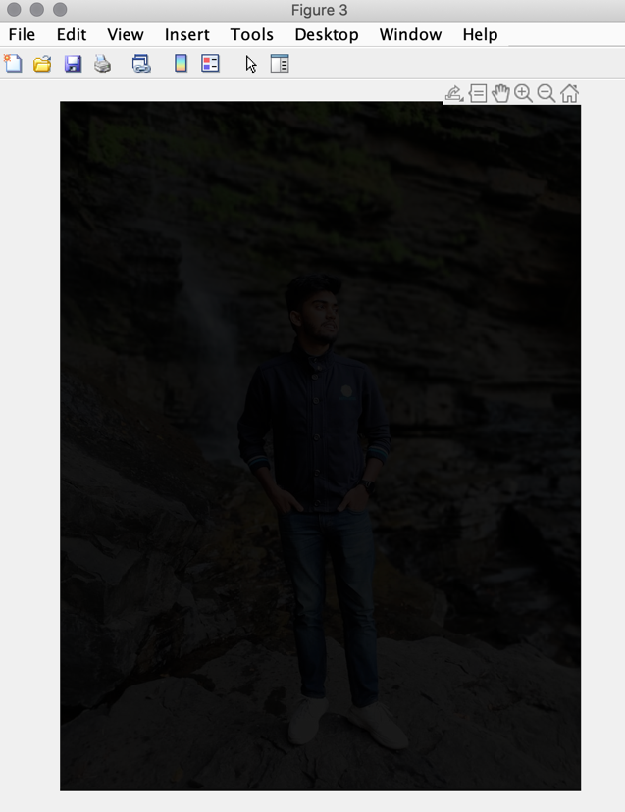

**b) By 50**

**c) By 255**

**Multiplication**

**a)By 10**

**b) By 20**

**c)By 255**

**Subplot collage**

1. **Workspace and matrix representation of an Image**

**B.3 Observations and learning:**

***(Students are expected to comment on the output obtained with clear observations and learning for each task/ sub part assigned)***

Learned to use basic commands in matlab like how original image is converted into gret scaled iumage, and dimensions of the image is changed wrt arithmetic functions.

**B.4 Conclusion:**

*(****Students must write the conclusion as per the attainment of individual outcome listed above and learning/observation noted in section B.3)***

Learned to use basic commands in matlab like how original image is converted into gret scaled iumage, and dimensions of the image is changed wrt arithmetic functions.

**B.5 Question of Curiosity**

***(To be answered by student based on the practical performed and learning/observations)***

Q1: List out possible real life applications of mathematical operations you have performed on the images

a)To increase the intensity of the image for more visibility

b)Conversion of the image to proper size and format according to the usage norms

Q2: What output you can get if you perform following logical operations on images:AND/NAND, OR/NOR, XOR/XNOR and logical NOT.

AND,OR,NOT,XOR

